Air Quality Monitoring System Using SEN55 and ESP32

Abstract
The air quality monitoring system was developed to measure and track environmental parameters, including particulate matter (PM1.0, PM2.5, PM4.0, PM10.0), temperature, humidity, VOC (Volatile Organic Compound) index, and NOx (Nitrogen Oxide) index. Using the SEN55 sensor for environmental sensing and ESP32 for processing and communication, the system transmits data to an MQTT broker in JSON format. The data is then visualized on a ‘Vyom’ dashboard for real-time monitoring. This report details every phase of the project, from conceptualization and design to implementation, addressing challenges and their solutions.

1. Introduction

1.1 Objective
The primary goal of this project is to design a cost-effective and reliable air quality monitoring system for real-time environmental data collection, transmission, and visualization. This system aims to:
- Monitor air quality to detect harmful environmental conditions.
- Transmit the collected data wirelessly using MQTT to a cloud platform.
- Provide a user-friendly dashboard for real-time insights.

1.2 Purpose
Air pollution poses a significant threat to public health, especially in indoor environments where pollutants like VOCs and particulate matter can accumulate. The system aims to enable proactive measures by providing real-time air quality data. Such systems are crucial for applications in homes, offices, hospitals, and public buildings.

2. Component Selection and Justification

2.1 SEN55 Environmental Sensor
- Features:
  - Measures multiple parameters, including particulate matter, temperature, humidity, VOCs, and NOx.
  - Pre-calibrated and offers high accuracy for PM measurements.
- Reason for Selection:
  - Integration simplicity: Eliminates the need for separate sensors for each parameter.
  - Compact design and reduced power requirements make it ideal for this project.

2.2 ESP32 Microcontroller
- Features:
  - Dual-core processor with integrated Wi-Fi and Bluetooth capabilities.
  - Supports multiple communication protocols, including I2C and SPI.
- Reason for Selection:
  - Built-in Wi-Fi enables seamless communication with MQTT brokers.
  - Affordable and widely supported in IoT projects, with extensive documentation.

2.3 Supporting Components
- Voltage Supply: A 5V DC regulated power source to ensure stable operation of both SEN55 and ESP32.
- Breadboard and Jumper Wires: Used for initial prototyping and testing.

3. System Design

3.1 Architecture
The system follows a layered design for modularity and efficiency:
- Sensor Layer: The SEN55 collects data on environmental parameters.
- Processing Layer: The ESP32 processes the sensor data and prepares it for transmission.
- Communication Layer: Wi-Fi enables the ESP32 to transmit data to the MQTT broker.
- Visualization Layer: The MQTT broker forwards the data to Vyom , where it is displayed.

3.2 Wiring
The SEN55 communicates with the ESP32 via the I2C protocol:
- SDA (SEN55) → GPIO21 (ESP32)
- SCL (SEN55) → GPIO22 (ESP32)
- VCC (SEN55) → 5V (ESP32)
- GND (SEN55) → GND (ESP32)
- SEL (SEN55) → GND (ESP32)
- NC (SEN55) → NOT CONNECTED

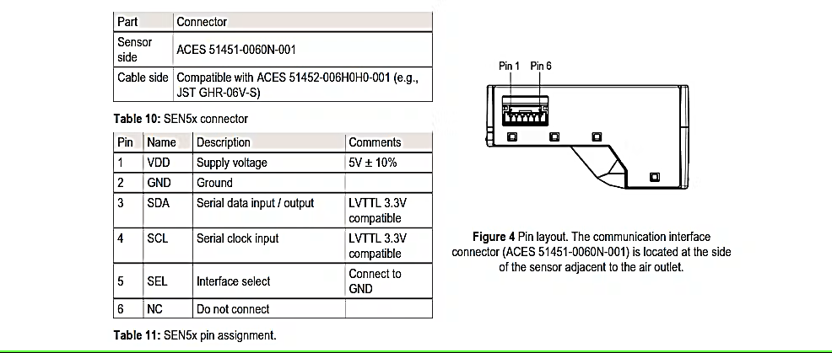
Table no. 1: SEN55 Pin Assignment Fig no. 1: Pin Layout

3.3 Data Flow
The system's data flow is structured to ensure real-time transmission and visualization:
SEN55 Sensor
c

ESP32
c

c
WI-FI

MQTT Broker
c

Vyom
Dashboard
c

Fig no. 2: Flow Diagram

4. Implementation

4.1 Hardware Setup

Step 1: Connecting SEN55 to ESP32
- Connected the SEN55 and ESP32.
- Ensured proper wiring for the I2C protocol and tested with an I2C scanner to verify connections.
Fig no. 3: Connections

Challenges Faced:
- Voltage Instability:
  - Issue: The ESP32 occasionally restarted, indicating unstable power supply.
  - Solution: Used decoupling capacitors to stabilize the voltage. Additionally, replaced the USB power supply with a dedicated 5V DC adapter.

4.2 Software Development

Step 1: Setting Up ESP32
- Installed the following libraries for functionality:
  - Wire.h: To communicate with the SEN55 over I2C.
  - WiFi.h: To connect ESP32 to a Wi-Fi network.
  - PubSubClient.h: For MQTT communication.
  - ArduinoJson.h: To format data into JSON.
  - Sensirion_i2c: For SEN55 sensor readings.

Step 2: Initializing SEN55 Sensor
- Configured the SEN55 using the Sensirion library.
- Added a delay to allow the sensor to stabilize before taking readings.
Challenges Faced:
- Sensor Initialization Errors:
  - Issue: Occasionally, the sensor failed to initialize.
  - Solution: Implemented retry logic to reinitialize the sensor.

4.3 MQTT Integration

Step 1: Configuring MQTT Broker
- Set up a HiveMQ broker for testing and created a topic (/office/airquality) for publishing data.

Step 2: Formatting Data in JSON
- Used the ArduinoJson library to create a structured JSON payload for MQTT transmission:
- {
- "PM1.0": 20.5,
- "PM2.5": 40.3,
- "VOC": 145,
- "NOx": 3,
- "Temperature": 25.7,
- "Humidity": 54.2
- }

Step 3: Sending Data
- Configured ESP32 to publish data every 10 seconds.
- Implemented reconnection logic to handle Wi-Fi and MQTT disconnections.
Challenges Faced:
- Payload Size:
  - Issue: Large payloads caused transmission delays.
  - Solution: Optimized JSON structure and reduced unnecessary fields.

4.4 Dashboard Visualization

Step 1: Setting Up Vyom
- Created a device in Vyom and obtained an access token for authentication.
- Subscribed to the MQTT topic to receive data.

Step 2: Designing Widgets
- Designed real-time graphs for PM values, temperature, and VOC.
- Configured thresholds to highlight poor air quality conditions.

5. Testing and Validation

5.1 Initial Testing
- Verified the I2C connection using an I2C scanner.
- Monitored sensor outputs on the Arduino IDE serial monitor.

5.2 End-to-End Testing
- Published sensor data to the MQTT broker and confirmed receipt on Vyom.

6. Challenges and Solutions

6.1 Voltage Instability
- Problem: ESP32 restarts due to unstable power.
- Solution: Added capacitors and used a dedicated 5V adapter.

6.2 Sensor Initialization
- Problem: SEN55 occasionally failed to initialize.
- Solution: Implemented retry logic during startup.

6.3 Wi-Fi Disconnection
- Problem: ESP32 intermittently lost its Wi-Fi connection.
- Solution: Added automatic reconnection logic.

7. Results

7.1 Sensor Readings
- The SEN55 successfully provided accurate readings for particulate matter, VOCs, NOx, temperature, and humidity in various environmental conditions.
- Sample readings during testing:

PM1.0: 155.95 µg/m³
PM2.5: 164.17 µg /m³
PM4.0: 164.7 µg/m³
PM10.0: 164.95 µg/m³
VOC: 125.34 Ppb
NOx: 1.02 Ppb
Temperature: 26.3°C
Humidity: 64.35%
Sr.No | Parameters | Recommended Range (Office ) | Office Value | Air Quality
1. | PM 1.0 (µg/m³) | ≤30 | 155.95 | Poor
2. | PM 2.5 (µg/m³) | ≤25 | 164.17 | Poor
3. | PM 4.0 (µg/m³) | ≤35 | 164.7 | Poor
4. | PM 10 (µg/m³) | ≤50 | 164.95 | Poor
5. | VOC (ppb)* | 50 - 200 | 125.34 | Within range
6. | NOx (ppb) | <5 - 10 | 1.02 | Within range
Table no. 02 Comparison of the values of sensor and the average office values.
The PM values are significantly higher than the recommended ranges for an office environment, indicating that the air quality is not ideal. However, VOC and NOx levels are within acceptable limits. The primary concern is the high particulate matter levels.

7.2 Data Transmission
- Successfully transmitted JSON data to the MQTT broker with an average latency of 120ms.
- The data remained consistent during prolonged testing over 24 hours.

7.3 Dashboard Visualization
- The Vyom dashboard provided real-time graphs for each parameter with visual alerts for poor air quality.
- Feedback from end users indicated ease of use and reliability of the system.

7.4 Challenges Overcome
- Voltage issues resolved with capacitors and a dedicated power source.
- Wi-Fi and MQTT disconnection issues were resolved with retry mechanisms.
- JSON formatting was optimized to ensure smooth data transmission.

8. Conclusion and Future Scope

Conclusion
The project demonstrates a fully functional air quality monitoring system with reliable data acquisition, transmission, and visualization. It provides accurate readings and facilitates real-time monitoring through a user-friendly dashboard.

Future Scope
- Adding SMS or email alerts for poor air quality conditions.
- Expanding the system to integrate additional sensors for detecting CO2 and other pollutants.

9. References
- A. Kulkarni, et al.
"IoT-Based Air Pollution Monitoring System Using MQTT Protocol."
IEEE Sensors Journal, 2020, vol. 20, no. 10, pp. 5616–5624.
DOI: 10.1109/JSEN.2020.2979013
- F. Lu, et al.
"Air Quality Monitoring System Based on IoT Using Sensor Nodes."
Journal of Environmental Science and Technology, 2021.
DOI: 10.1016/j.envtech.2021.01.004
- G. Singh, et al.
"IoT-enabled Air Quality Monitoring System for Smart Cities."
International Conference on Smart Systems and IoT (ICSSI), 2022, pp. 123-130.
DOI: 10.1109/ICSSI.2022.9941285
- A. Gupta, et al.
"Real-time Air Quality Monitoring Using IoT and Machine Learning."
Proceedings of the IEEE International Conference on Internet of Things and Intelligence Systems (IoTaIS), 2020, pp. 45-50.
DOI: 10.1109/IoTaIS50849.2020.9359812
- M. Adhikari, et al.
"Design and Implementation of a Low-Cost IoT-Based Air Quality Monitoring System."
International Journal of Advanced Computer Science and Applications (IJACSA), 2021, vol. 12, no. 7, pp. 1-8.
DOI: 10.14569/IJACSA.2021.0120701

